Unzip LMF_Deploy to your C:\ drive.

Left click on the Windows Start icon at the lower left of your screen.

Search for cmd in the bottom “Search Programs…” box.

When cmd.exe appears, right click on it. Select “Run as administrator”.

Your cmd window should now look like this:

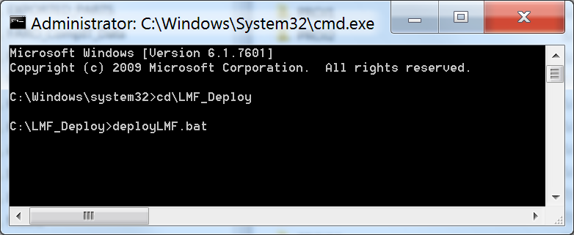

Hit the Enter key, and wait for the registration process to finish. You’ll see “Press any key to continue…”

When the process is done. Your window should now look like this:

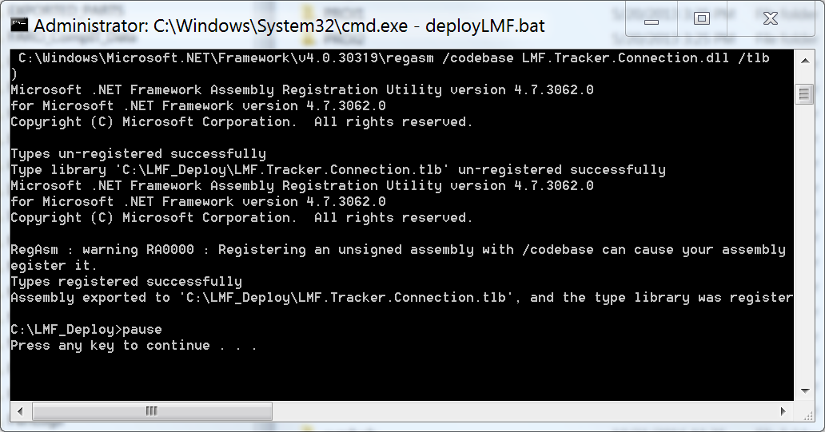

If so, you are ready to run. If not, please get a screen shot and send to support@kinematics.com